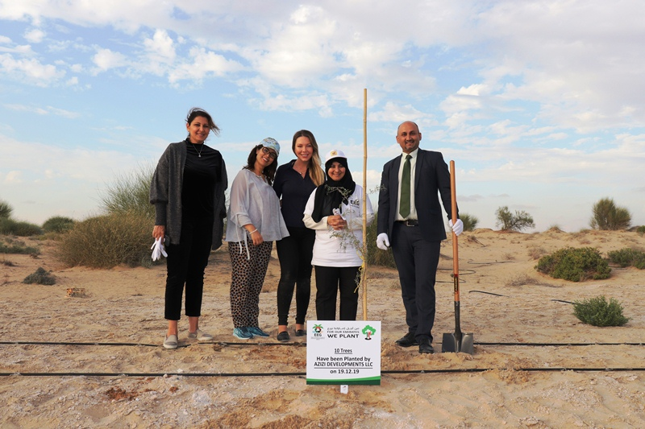

Clean-Up Drive and ‘For Our Emirates We Plant’

As an avid supporter of environmental best practices and sustainability initiatives, Azizi Developments was delighted to play its part in preserving the UAE’s ecosystem, contributing to the Emirates Environmental Group’s waste collection and indigenous tree planting efforts.

Clean-Up Drive
A team of 50 of Azizi Developments’ employees participated in a clean-up drive, helping to clean 18 sq km of land and remove 12.5 tons of waste. With this movement not just being about cleaning up, but also about raising global awareness and implementing lasting changes to end the global waste epidemic, Azizi is taking concrete steps to educate its employees on how they can best reduce waste.

For Our Emirates We Plant
Azizi also participated in the annual “For Our Emirates We Plant” initiative, organised under the kind patronage and presence of H. E. Engr. Sheikh Salem Bin Sultan Bin Saqr Al-Qasimi, member of the Executive Council of the Government of Ras Al-Khaimah and Chairman of the Department of Civil Aviation, Government of Ras Al Kahimah, at a beautiful Sidra nature reserve in Al Minei area. A second tree planting took place in the Emirate of Dubai at the famous Al Qudra Lakes, in which Azizi Developments participated. During the event, environmental enthusiasts representing different sectors of society – government and private entities, academic institutions, VIPs and students from all over the UAE – planted a total of 1,747 indigenous Sidra and Ghaf trees across the two sites. These trees, on maturity in 5-7 years, will help mitigate more than 37 MT of CO₂ emissions annually.

